**Ashfield Bicycle Users Group (AshBUG)**

Your Say Inner West

Local Area Traffic Management plan for Ashfield North and Croydon

Shirley Rodriquez

[shirley.rodriquez@innerwest.nsw.gov.au](mailto:shirley.rodriquez@innerwest.nsw.gov.au?subject=Website%20enquiry%20-%20Newton%20South%20LATM%20public%20exhibition)

Thank you for the opportunity to comment on the proposed LATM and what can be done to in Ashfield North & Croydon precinct.

We believe improved safety and calmed traffic can be achieved by:

* creating quiet streets around day care centres, aged care centres, and schools.

Example: the western end of Elizabeth St passes the Aquatic Centre, a day care centre and is a direct route to PLC. A 30kph speed zone would increase the safety of the many children in the area as well as reducing ‘rat-running’.

Example: All the streets shown in light green on the map below are already running at a median speed at or below 30kph and only need to be formally confirmed as 30kph speed zones.

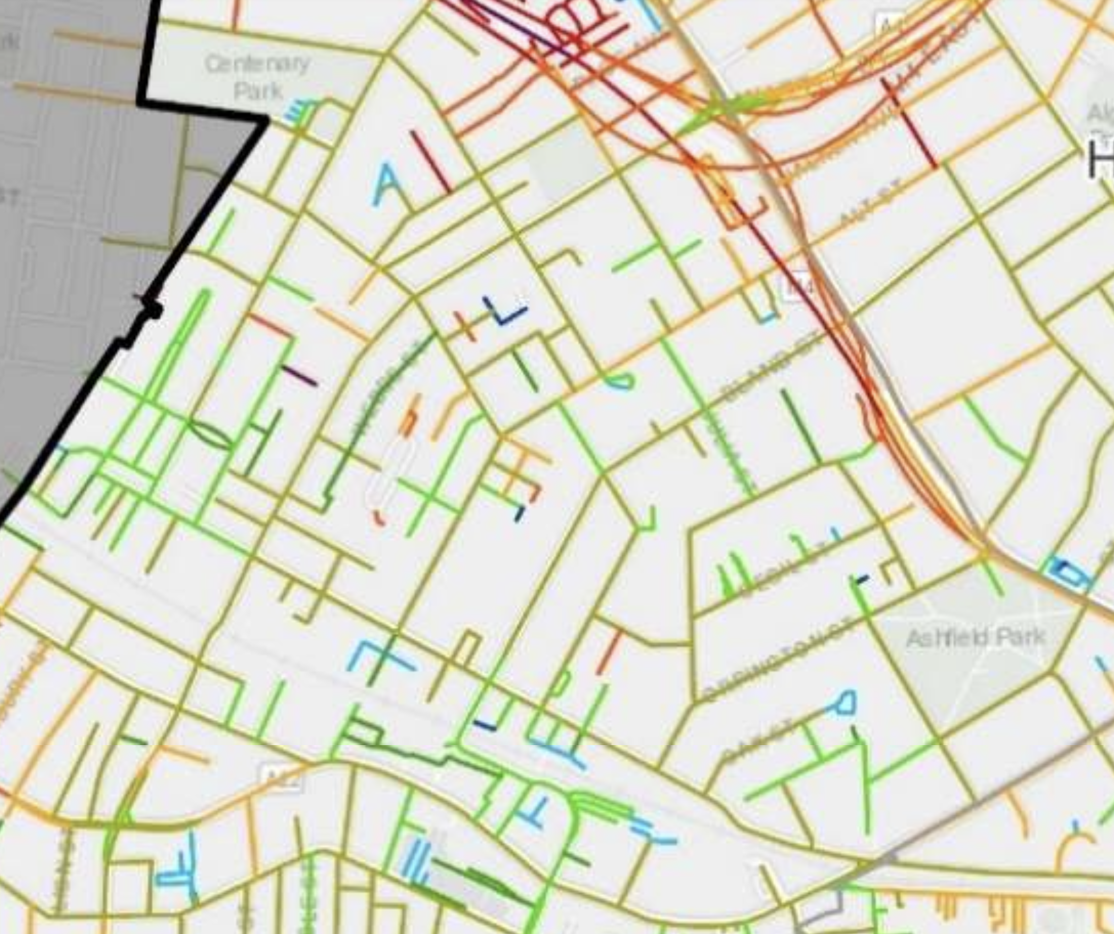

* removing impediments that inhibit the free flow of people walking and cyclists.

Example: Crossing Liverpool Rd. from Elizabeth St. to Grosvenor St. is confronting to all but the most experienced of cyclists. Separated cycle path, with refuges at traffic lights and smart traffic lights would help to make this crossing safer.

Example: Install mid-block pedestrian/cycle crossings with traffic lights on Parramatta Road near Alt Street, Chandos Street and Rogers Avenue.

* creating safe access to green spaces and shopping centres.

Example: Access into Ashfield Park is difficult across wide and busy streets. Pedestrian/cycle crossings across Orpington St at the corner of Loftus St., and across Ormond St. at the corner of Gower St. are required.

Example: There is not a safe and convenient cycle route from the north into Ashfield shopping centre. A separated cycle path along Brown St. under the railway would promote cycling as an alternative to shopping by car.

* creating safe and convenient cycling corridors across the precinct.

Example: There is no clear north-south link across the precinct. Iron Cove Creek is an obvious opportunity, so too is Alt St.

Example: Elizabeth St. has been identified as a priority cycling corridor by TfNSW as an east-west link and would connect the Aquatic Centre to the Greenway.

Heavy traffic volumes that are leaving main roads to cross the precinct to outside destinations (rat-runners) are causing havoc and need to be slowed down. Lower speed limits and priority to vulnerable children and adults and people walking and cycling will result in less traffic moving at lower speeds.

Terry Freshwater

President

Ashfield Bicycle Users Group